Day -3

1. Write a program to sort an array of integers in ascending order using pointers.

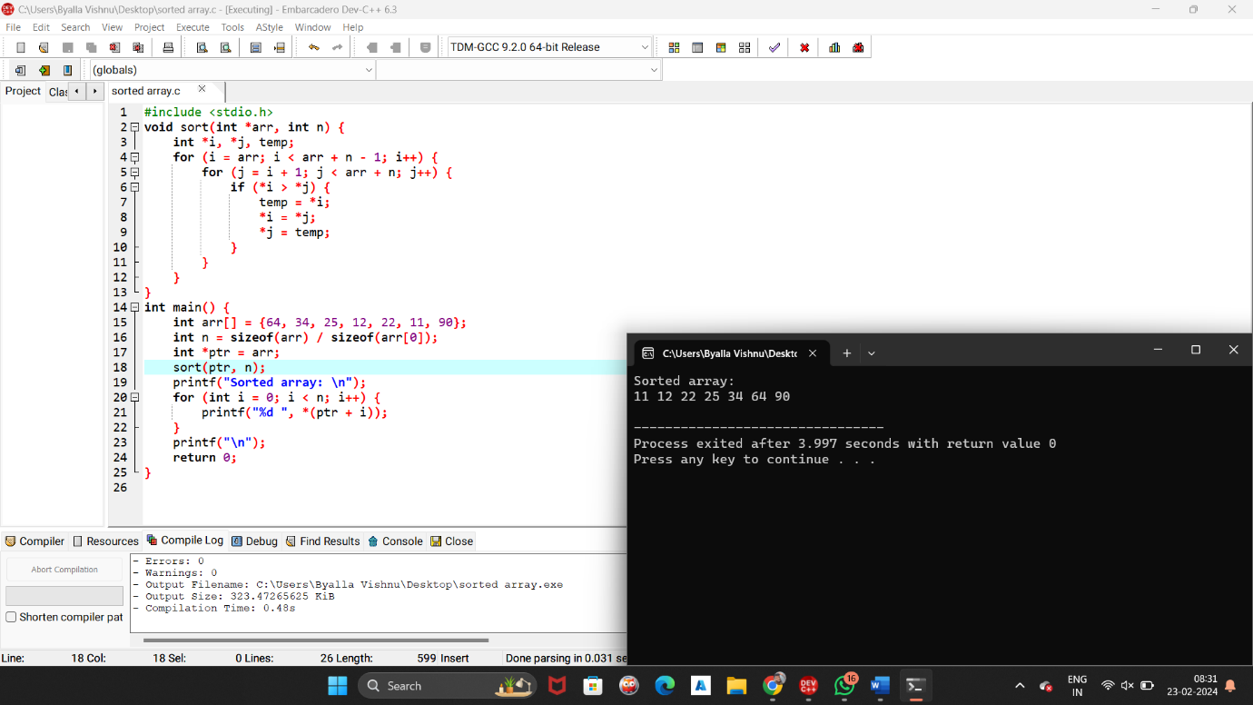

1. Write a program to find the factorial of a number using pointers.

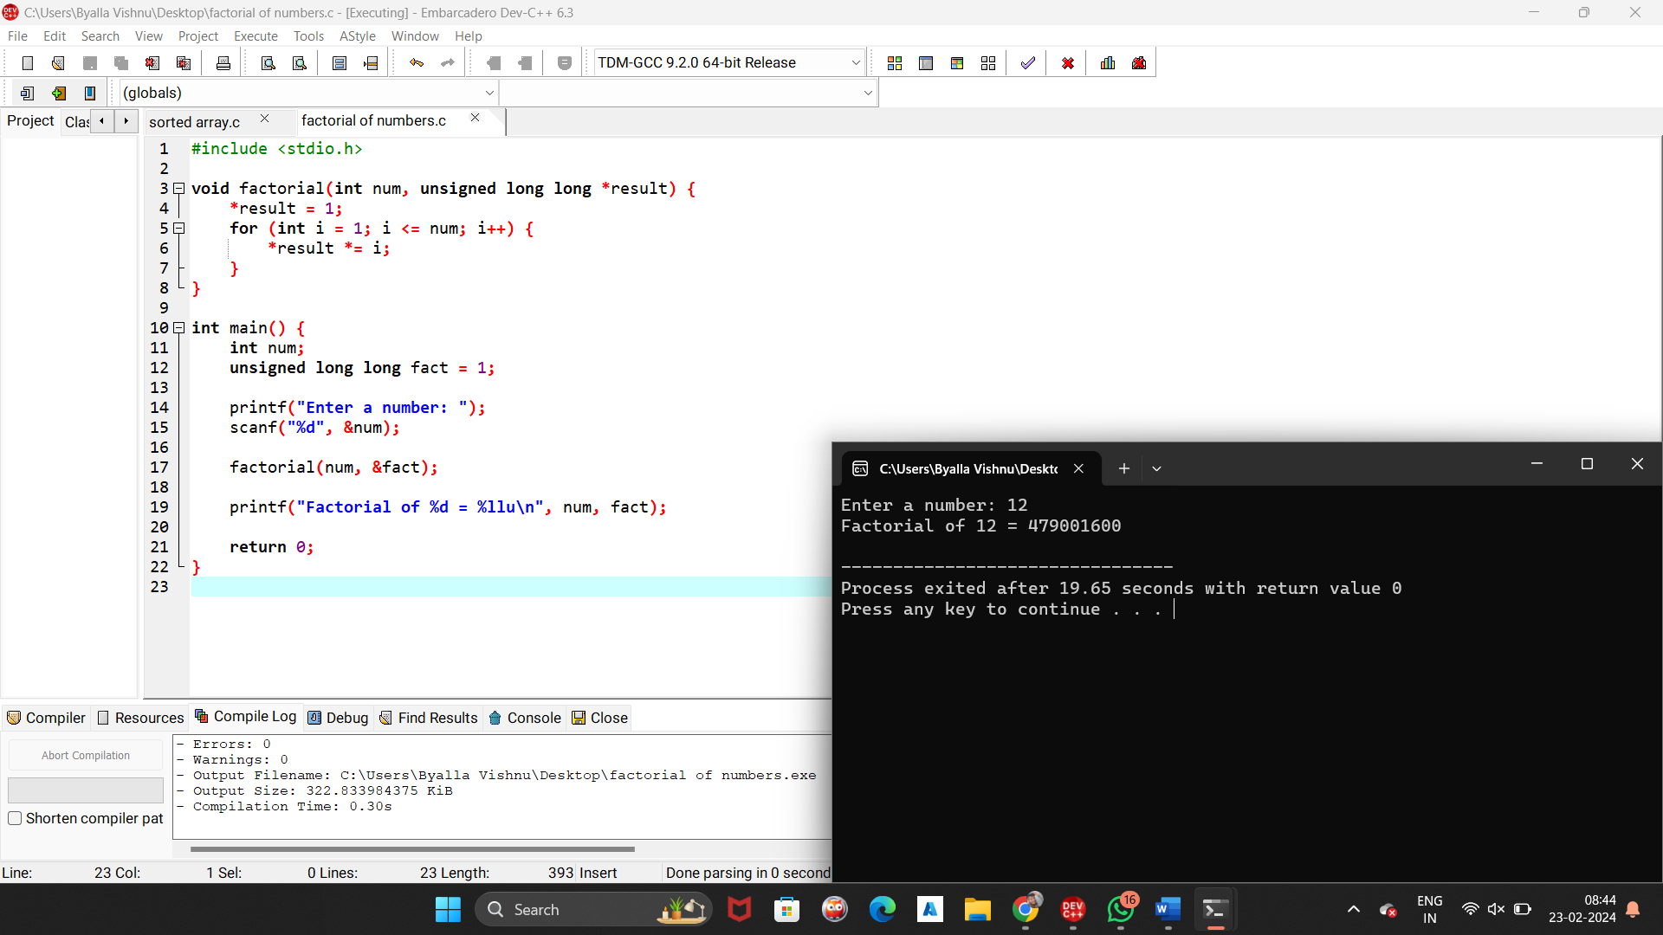

1. Write a program to check if a given number is prime using pointers

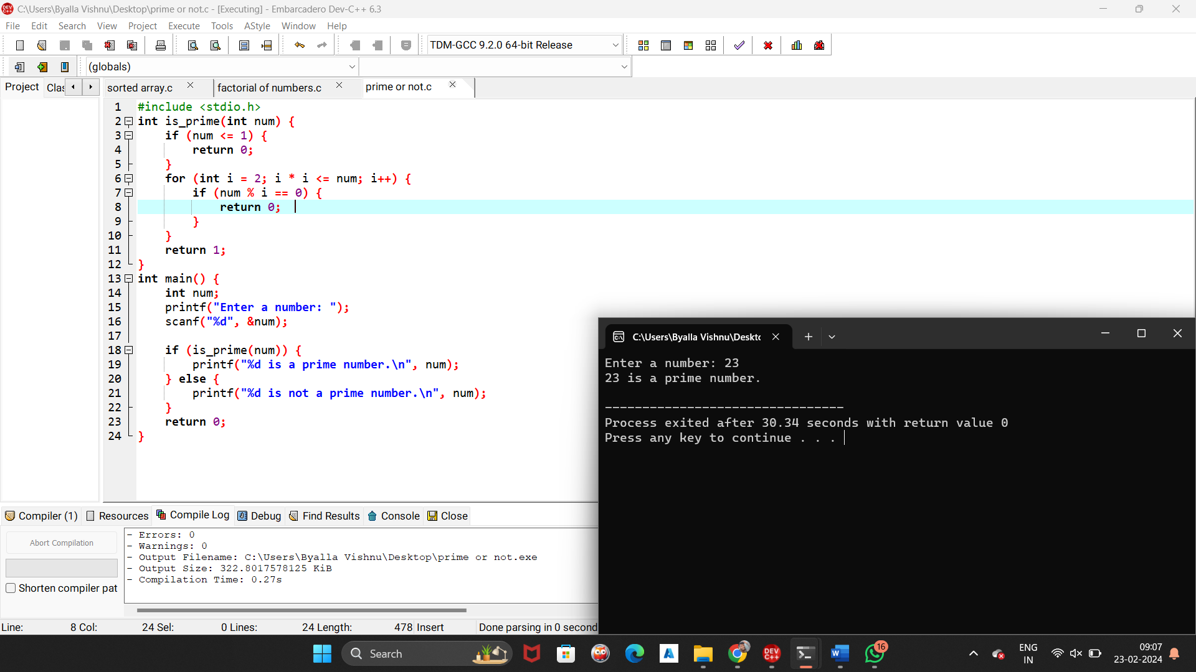

1. Write a program to concatenate two strings using pointers.

